# NOTICE TO SHIPS BOUND FOR PONTA UBU TERMINAL

1. *All ships intending to berth at Ponta Ubu Terminal must be vetted/evaluated and approved by Samarco upon owners nomination and prior to acceptance to call the Terminal.*

*In order to support the vetting system the vessels should send the certificates and/or documents below.*

*General Arrangement Plan; Certificate of P&I Club member of International Group; Capacity plan* ***including total existing Fuel and MGO*** *in each tank. Ship security plan (ISPS code), Safety Management certificate (ISM code); Document of compliance (ISM code) Oil Pollution prevention certificate; Classification certificate; Certificate of compliance (IMSBC code); Loadline certificate; International Ballast Water Management Certificate.*

*Note 1 - Terminal Authority can require additional information.*

*Note 2 - Discharge vessels must send certificates concerning cranes tasks as well.*

Navios e embarcações de porte que pretendam atracar em P. Ubu precisam ter sido submetidos e aprovados previamente pelo Sistema de vetting da Samarco. Para prosseguir com análise de vetting, os navios devem remeter os documentos abaixo:

General Arrangement Plan; Certificate of P&I Club member of International Group; Capacity plan **including total existing Fuel and MGO** in each tank. Ship security plan (ISPS code), Safety Management certificate (ISM code); Document of compliance (ISM code) Oil Pollution prevention certificate; Classification certificate; Certificate of compliance (IMSBC code); Loadline certificate; International Ballast Water Management Certificate.

Nota 1 – A Administração do terminal poderá requerer informações adicionais.

Nota 2 – Navios que farão descarga devem enviar também os certificados relacionados com as atividades de guindar.

1. *Ships with any deck obstruction between the hatch cover n.1 and the superstructure (above the hatch coamings height), shall include sketches or plans with identification of the obstructions and respective dimensions. See also the Harbor Particulars (Annex 1).*

Navios com qualquer obstrução acima das escotilhas entre o porão n° 1 e a superestrutura devem incluir esquemas e/ou planos identificando estes obstáculos e suas dimensões. Veja as especificações do terminal (anexo 1)

1. *Cargo ships shall send to Samarco team their Cargo Plan Form (Annex 7) filled to be analyzed, at least 7 consecutive days before their ETA at Ponta Ubu. The Terminal might require changes for improvement of productivity, which do not affect operational safety codes. Besides, the Capitan’s previous approval is always necessary for any change in the cargo plan.*

Navios de carga devem remeter o Plano de Carga de acordo com o anexo 7, em até sete dias antes do ETA. O terminal poderá requerer modificações objetivando produtividade, sem comprometer a segurança. Todas as modificações propostas devem ser sempre previamente aprovadas pelo Comandante.

1. *Ponta Ubu Terminal do not accept Cargo Plan exceeding the shearing force and the bending moment according to table 1 (below).*

O terminal de Ponta Ubu não aceita Planos de Carga com valores máximos de Momento Fletor e Esforço Cortante, segundo a tabela 1 (abaixo)

Table 1 / Tabela 1- Maximum Bending Moment and Shearing Force / Momento Fletor e Esforço Cortante Máximo Permitidos.

|  |  |  |  |
| --- | --- | --- | --- |
| Age of Vessels | **> 20 years** | **15< and ≤ 20 Years** | **≤ 15 years** |
| Bulk Carrier | 93% | 96% | 99% |
| Oil Bulk Oil (OBO) | 91% | 94% | 98% |

1. *Deballasting (Total) time should be faster than the time planned for loading, taking into consideration the values determined as attached (Annex 2). Nevertheless, any time requested for deballasting will be considered as ‘packages’ of no less than 3 hours. However, it can restart before by Terminal’s convenience and Vessel’s concordance.*

Tempo total de deslastro deve ser inferior ao tempo de carregamento planejado, considerando os valores definidos no anexo 2. Não obstante, qualquer tempo de deslastro requerido será considerado em pacotes com tempo mínimo de 3 horas cada um deles. Podendo o carregamento reiniciar antes deste período, se autorizado pelo navio.

1. *Ship draft marks and holds’ numbers identification shall be in good conditions, clearly visible and adequately illuminated. Cargo reserved for trimming shall be about 3.0 % of total load. Trimming should be completed at the end holds, or as near to the ends as possible.*

As marcas de calado e identificação dos porões devem estar em boa ordem, claramente visíveis e iluminadas adequadamente. A carga reservada para trimming deve ser aproximadamente 3,0% do carregamento total e, deverá ser feito utilizando os porões extremos ou, o mais próximo possível deles.

1. *Procedures considered normal and adequated for draft survey are :*

*The initial reading prior to loading;*

*Another reading at the beginning of trimming; and*

*One upon completion of loading.*

*No other draft survey shall be performed that could impair loading, except in case of unpredictable instances such as ships with different cargo loads and/or several clients.*

Procedimentos considerados adequado e/ou usuais para leituras dos calados da arqueação são :

Inicial, antes do carregamento;

Leitura no início do processo de trimming; e

Ao final, para concluir o carregamento.

Nenhuma outra leitura poderá ser solicitada impactando a sequência de carregamento, exceto se condições excepcionais, como quando houver mais de uma carga ou cliente.

1. *Ships with different types of cargo shall try to obtain their loading sequence in order to finish the first one before the second cargo brand starts. The same situation should be done until the last cargo. If the cargo list includes Ore Pellets this cargo should be the first one to be loaded.*

Navios com mais de um tipo de carga deverão planejar o carregamento de forma a concluir cada uma delas antes de iniciar o próximo lote da sequencia. Em havendo pelotas de ferro entre as cargas, esta deverá ser a primeira a ser carregada.

1. *The terminal nominal average loading rate is 12,500 t/h. Loading rates (pour) declared as port uses and practices vary according to ship’s size and follow the loading rates table attached (Annex 2).*

A taxa nominal de carregamento de Ponta Ubu é de 12.500 t/h. As taxas de carregamento declaradas como usuais e praticadas variam conforme a dimensão do navio de acordo com a tabela em anexo (Anexo 2)

*Masters should declare to the terminal their awareness about terminal particulars and rules.*

Os Comandantes deverão declarar ciência das particularidades e regras vigentes do terminal.

1. *The length for loading at both wharf berths are the same: Shiploader moves over the rail until up to 279.5m.*

O comprimento para carregamento é o mesmo em ambos os berços. O shiploader translada por até 279,5m.

1. *Vessels narrower than 32,0m meters (breadth) should alongside south heading at ordinary berthing maneuver (portside at the West side (closer than the beach) and starboard side if East side).*

Navios para serem carregados que possuam boca inferior a 32,0m, deverão atracar aproados para o sul nas manobras de rotina (bombordo no lado oeste e boreste no lado leste).

1. *Compulsory conditions to vessels intending to load cargo of the Group “A” of IMSBC-Code: LoA ≤ 293,0m and Breadth ≤ 46,0m.*

Condições obrigatórias para navios que irão carregar cargas do grupo “A’ do IMSBC-Code: Comprimento todo (LoA) ≤ 293,0m e Boca ≤ 46,0m.

*In cases of rain, the decision to close holds shall be at the terminal discretion, always underpinned on the pluviometer results, cargo moisture and TML situation.*

Em caso de precipitação, a decisão de fechar os porões deve ser a critério do terminal, sempre respaldado nos indicadores do pluviômetro, condições de umidade e TML da carga em questão.

1. *Ships in “gas free” condition shall take the necessary measures for issuing and submitting the Gas free Certificate document, without it the ship will not be considered ready in all aspects to berth/load. Therefore, any waiting time will not count as laytime or time on demurrage.*

Navios na condição “gas free” devem enviar o Certificado compatível. Sem este documento, o navio não será atracado, nem será considerado pronto a operar em todos os aspectos. Então, qualquer tempo de espera decorrente deste fato não será considerado no cômputo para *laytime* ou *demurrag*e.

*However, if there is no flammable cargo since the last three cargoes, vessels should only send a Master’s declaration in accordance with requirements of SOLAS. The statement will take in trust.*

Entretanto, caso não tenha havido carga inflamável nas últimos 3 carregamentos, o navio poderá se valer apenas da declaração do Comandante, conforme previsto no SOLAS, e que será aceita em boa fé.

1. The foreman will be fully available, however in any emergency situation that loading must be stopped, it can be done using “Zulu” whistle signal :

2 long and 2 short ( - - .. )

A despeito da disponibilidade plena do *foreman* (inspetor), qualquer situação emergencial que requeira a parada de carregamento poderá ser sinalizada com o apito do sinal (Zulu):

2 longos e 2 curtos ( - - .. )

1. *Minimum mandatory freeboard is 4.50 m.*

A menor borda livre aceitável é de 4,50 m.

1. *For vessels above 30,000 tons (deadweight) there are different wind speed and wave heights limits to ordinary berthing maneuvers for East Side and West side (table 2).*

Para navios acima de 30.000 t (Porte Bruto), a velocidade máxima de vento e da altura significativa das ondas para atracações ordinárias são diferentes para os lados Leste e Oeste (vide abaixo)

*Table 2 / Tabela 2 – Maximum weather conditions for ordinary ship manoeuvers / Condições ambientais máximas permitidas para manobras usuais.*

|  |  |  |
| --- | --- | --- |
| PARTICULARS | EAST SIDE | WEST SIDE |
| Max Wind Speed | 23 Knots (East hemisphere) | 28 Knots (West hemisphere) |
| Max. Significant Wave Height | 1,8 m (Northeast quadrant) | 1,8 m (Northeast quadrant) |

*Berthing and Unberthing vessels must require a tug service according to the table available at Samarco website.*

Os Navios em manobras de atracação ou desatracação precisam requerer o serviço de rebocadores de acordo com a tabela disponível no site da Samarco.

### OTHER RELEVANT INFORMATION / OUTRAS INFORMAÇÕES IMPORTANTES:

*All material and/or service supply shall be made in compliance with relevant legal requirements and harbor rules, and shall cause no operational delays.*

*Cargo should not handle by sea/hull or using gang way or pilot ladder.*

Todo material e/ou serviço requisitado deve estar em concordância com os requerimentos legais relevantes e as regras do terminal. E, não devem ocasionar atrasos.

Não é permitido movimentação de carga pelo bordo do mar ou com o uso da escada de quebra-peito.

1. **Images**

*There are many high quality cameras around the terminal and Remotely Piloted Aircraft Systems (drones) devices in order to guarantee safety, security (ISPS-code) and environment control. However, the use of other drones is not allowed for safety reasons.*

Há várias cameras de alta qualidade e Drones (Remotely Piloted Aircraft Systems) objetivando garantir a segurança patrimonial, ISPS-code e melhor controle ambiental. Entretanto, não é permitido o uso de outros drones, por razões de segurança.

### *Allowance for accessing ships*

*Access to the ship is not allowed without the Captain’s (or his representative’s) approval, for the ship’s own safety and control. Thus, the permit shall be individual (nominal) and not transferable. The request shall be made via email (sent to autporto@samarco.com) 24 hours in advance.*

O acesso a bordo não é permitido exceto se com anuência do Comandante (ou seu representante). Desta forma, a permissão deve ser individual (nominal) e intransferível. A solicitação pode ser feita por email ([autporto@samarco.com](mailto:autporto@samarco.com)) com 24 horas de antecedência.

### Oil to the vessels

*The supply (and removal) of oily material shall be made by means of sealed drums. Pumping oil or oily waste is only allowed in the terminal in compliance with a series of additional and mitigating requirements, in case of an accident previously agreed with the terminal at least 48 hours in advance*.

O fornecimento (ou remoção) de material impregnado de óleo deve ser feito com tonéis selados. Óleo bombeado e/ou resíduo oleoso só é permitido em anuência, e com uma série de requerimentos adicionais e mitigadores para o caso de acidente, previamente acordados com o terminal com antecedência de 48 horas.

Exceptional situation should be previously agreed with the Terminal Authority.

Situação excepcional deve ser previamente acordada com a administração do terminal.

### Diving around the ships:

*It shall always be monitored by Samarco personnel and shall be requested at least 48 hours in advance.*

É compulsório a atividade ser monitorada por profissionais da Samarco (ou indicados por ela) e, deve ser requerida com 48 horas de antecedência.

### Waste removal

*Shall only be carried out through the secondary entrance gate, even if it is transported by small vehicles, and only during day shift, with weighing being performed both when accessing and leaving Samarco and further issuing of the waste final disposal confirmation within 48 working hours, at the most.*

Retirada de resíduo dos navios deve ser pela Portaria Industrial (secundária) mesmo se usando carros de pequeno porte e apenas no horário diurno. Deve ser pesada na entrada e na saída. Deve também ser informada a destinação final do produto em até 48 horas.

### Cleaning anchor chain and external hull marine growth and painting

*It is not allowed in the area under Samarco’s responsibility terminal*.

Não é permitido a limpeza das amarras e/ou do costado do navio na área do terminal.

### Cleaning hold comings and hatches, decks and adjoining areas

*Cleaning with compressed air jet spreads particulate matters that contribute to the pollution of surrounding waters and beaches. Therefore, it is not allowed until the ship has passed by the last pair~~s~~ of buoys (canal exit).*

A limpeza *com ar comprimido projeta partículas que contribuem pelo aumento de poluição da area do entorno, o que a faz ser proibida até o que o navio passe pelo primeiro par de boias.*

### *Repairs Onboard*

*Repairs that pose risk to safety, as hot work and others, shall be previously agreed with the terminal. Works that may partially or completely impair the ship’s operational capacity also require previous written authorization, where the ship will assume responsibility for all costs directly or indirectly related to the repair (Annex 3).*

Reparo*s que coloquem em risco a segurança, tais como trabalhos “a quente”, devem ser previamente autorizados pela administração do terminal. E, trabalhos que afetem a capacidade operacional plena ou parcial do navio requer uma autorização por escrito, onde a embarcação assume a responsabilidade por todos os custos direta ou indiretamente relacionados com o reparo em questão.*

### *Movement of the Crew*

*Members of the crew and other people moving around must wear shoes, pants and shirts and must be aware of the safety about conveyor belts risk.*

*Tripulantes e afins, ao se movimentarem pelo terminal, deverão calçar sapatos fechados, calças compridas e camisas com mangas. E, devem se manter atentos as correias transportadoras e seus riscos relativos a segurança.*

### Simulation Drills

*Simulation drills that may interfere with the terminal routine, including such as life boats, boats, external* *firefighting, etc shall be previously discussed. Terminal simulation drills shall be previously informed to Captains of ships that have been moored and/or anchored, as relevant. (see Annex 4).*

*Simulações que possam interfirir na rotina do terminal, tais como as que fazem uso de botes, salva-vidas e combate a incêndio deverão ser previamente acordados com o terminal. As simulações do terminal serão previamente informadas aos comandantes de embarcações atracadas, e/ou fundeadas que sejam pertinentes.*

### Wire ropes during mooring

The terminal shall be previously informed about ships that use wire ropes for mooring. Pier bollards (SWL) is 150 tf and quick release hooks SWL is 100 tf. The mooring arrangements must be suitable with those values.

O terminal deverá ser previamente informado sobre navios que utilizam cabos de aço na amarração. Os cabeços possuem SWL de 150 tf e, os gatos, de amarração 100 tf. O arranjo de amarração deverá considerer estes valores.

### Ship Inspection (LVS)

*Almost all ships at Ponta Ubu are subject to inspection to be carried out by the port team, and might have their ballast water sampled for analysis. (see Annex 5).*

Praticamente todos os navios em P. Ubu estarão sujeitos a inspeções feitas pelo pessoal do Porto, podendo ser requerida uma amostra do lastro. (ver Anexo 5)

### Ballast

*Removal of water in good condition and in compliance with Brazilian Maritime Authority Standard and rules is a procedure included in the terminal routine. However, water cannot be dumped on the quay or on port structures even when clear.*

O deslastro em boas condições, e em acordo com as normas e regras da Autoridade Marítima é prática incluida na rotina do terminal. Porém, o deslastro deve ser feito sem ser direcionado ao cais e superestruturas do porto, mesmo quando for água limpa.

### SOPEP Kit

*For possible environmental incidents the ship shall be adequately and proportionately equipped with SOPEP Kit. The use of dispersants is not allowed without previous authorization of the competent environmental authorities.*

Visando possíveis acidentes e incidents ambientais os navios devem disport de kit sopep adequado e proporcional. O uso de dispersantes não é permitido sem a prévia autorização das autoridades competentes.

### ISPS

*Pre-operational forms related to ISPS and the crew list shall be issued within four days before ETA. At the end of loading, Form C (ISPS Code, Annex 6) must be returned to the foreman filled up and signed.*

Os arquivos pré-operacionais referents ao ISPS-code e a lista de tripulantes deve ser enviada em até quatro dias antes do ETA (anexo 8). Ao final de carregamento os documentos pertinentes deverão ser entregues ao Inspetor de Embarque assinados.

### Waiting Vessels

There are three independent berths. Vessels queue is understood regarding the ship’s particulars and berth restrictions. Hence, First-Come-First-Served (FCFS) principle is applied as much as possible, but always concerning the words above mentioned.

Há três berços de atracação no terminal. A fila de atracação é entendida considerando as características e restrições. Assim sendo, o princípio de ordem de chegada será aplicado sempre que possível, porém relevando outras considerações.

### The observation of this instruction summary does not exempt the ship from her responsibilities, and the list of recommendations herein does not include all legal practices and requirements or those established by the terminal. Additional information should be taken with the named ship’s agent.

Observando este resumo de instruções não isenta navios de suas responsabilidades. Não constam nestas instruções todos os requisitos legais ou instruções do terminal. Informações adicionais poderão ser obtidas junto ao agente marítimo nomeado pelo armador.

**ANNEX LIST:**

* 1. Harbor Particulars Table
  2. Average Loading Rates Table
  3. Formal Authorization for Repairs
  4. Simulation Drill Formal Authorization
  5. Safety and Environment Check List
  6. Statement of Awareness
  7. Samarco Loading Plan Form
  8. Master Receipt

**ANNEX 1**

### HARBOR PARTICULARS TABLE

### 

**Discharge Information**

Grab’s capacity ≥ 10 cbm and ≤ 13.0 cbm (m3);

Grabs dimensions: length ≤ 3.0 m; width ≤ 3.6 m.

Suitable vessels particulars for bulk discharge Outreach ≥ 7.5 m and SWL ≥ 30 t;

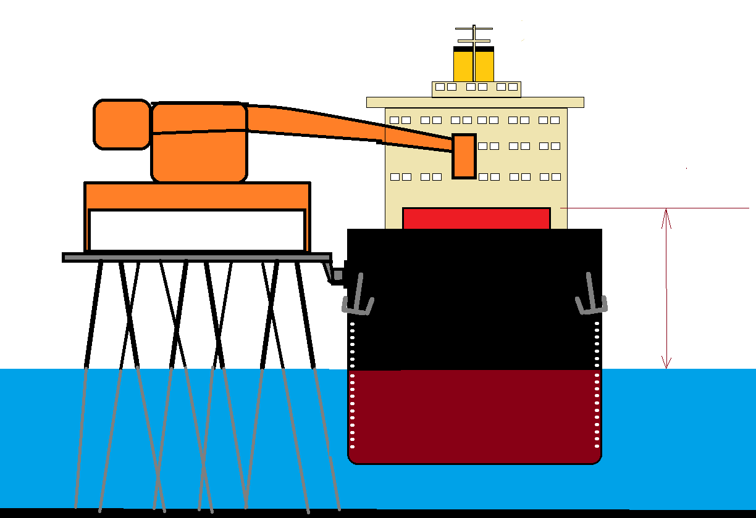

**ANNEX 2**

**AVERAGE LOADING RATES TABLE**

|  |  |
| --- | --- |
| **Vessels Range** | **Loading Rate** |
| DWT < 30,000 ton | 4,000 t/h |
| 30,000 < DWT < 53,000 t | 4,700 t/h |
| 53,000 < DWT < 80,000 t | 6,200 t/h |
| 80,000 < DWT < 130,000 t | 7,300 t/h |
| DWT > 130,000 t | 8,200 t/h |

Note: Vessels which have draft restrictions and will load less than 80% of the Summer Deadweight do not need to follow this rule.

**ANNEX 3**

**FORMAL AUTHORIZATION FOR REPAIRS**

## Ponta Ubu, , 20

*The Master of MV “ __”(vessel’s name) hereby declares his intentions to proceed with maintenance repairs which will require the immobilization of the vessel for hours which is less than loading time.*

*O Comandante do NM “__________________” (nome) declara intensão em fazer manutenções que irão require a imobilização do anvio por ___ horas, inferior ao tempo de carregamento e seu ETD (Estimated Time of Departure).*

*Therefore, in accordance with the Terminal rules, it means that it will happen under owner’s and captain’s supervision and in accordance with maritime law and rules and whatsoever costs that arise, directly or indirectly linked with that labor and/or any eventual delay will be under ship’s account.*

Assim sendo, de acordo com as regras do terminal, isto significa que irá ocorrer sob supervisão do comandante e da empresa. E, de acordo com a lei, regras e costumes maritimos os custos decorrentes desta atividade, indireta ou indiretamente relacionados, bem como atrasos serão de responsabilidade do navio.

Agree

Capt. Vessel´s Stamp:

**ANNEX 4**

**SIMULATION DRILL FORMAL AUTHORIZATION**

Ponta Ubu, , 20

*The Master of the M/V “______________________” hereby declares his intentions to carry*

*out the drill (drop the rescue boat, firefighting, etc.)*

*O Comandante do navio N/M “__________________” declara intensão de efetura exercício simulado (arriar baleeiras e similares, combate a incêndio, etc.)*

*However, in accordance with the Terminal rules, whatever happens with the life rafts, rescue boats, crew or any other device will be under owner´s and master‘s supervision and in accordance with maritime law and rules. Thus, Master agrees that whatsoever costs that arise, directly or indirectly linked with that drill and/or any eventual delay will be under ship's account.*

Entretanto, de caordo com as regras do terminal, sempre que houver esse tipo de atividade com embarcações salva-vidas, tripulação ou outro dispositivo similar, ele ocorrerá sob o comando e supervisão do Comandante, de acordo com as leis, regras e costumes. Assim sendo, o Comandante concorda que quaisquer custos e os eventuais atrasos relacionados direta ou indiretamente com a atividade são responsabilidade do navio.

Agree

Capt. Vessel´s Stamp:

**ANNEX 5**

Anchieta (Ponta Ubu), , ____

To: Master of M/V

From: Ponta Ubu Maritime Terminal

# Ref.: Safety and Environment Checklist

Welcome to Ponta Ubu Maritime Terminal. Below you will find important information that will make your stay more safer. Samarco Mineração S.A. strongly believes in a partnership work between Terminal and the berthed vessels. It also believes in a harmonious coexistence between port activities and preservation of the local environment.

1. Channel VHF 16 should be used for communication between vessel and Terminal.
2. If communication difficulties are found, the vessel can use two long followed by two short blasts to indicate emergency condition (- - ..) This will cause the loading operations to stop, among others.
3. At the sentry office there radio and telephone to be used in case of emergency, as well as to get urgent medical help, which is available 24 x 7.
4. There is a permanently pressurized fire system below the pier. Six hydrants, whose position is indicated by red lids, are alternately distributed between East and West berths.
5. One ASD 45BP tugboat is available full-time at the Terminal. If necessary, ask to foreman.
6. For bunkering operations, additional measures should be taken. The vessel or its Agent should ask for previous authorization at least 24 hours before the operations, by e-mail “porto.adm@samarco.com”.
7. Internal operations involving bunker, diesel oil and/or oily residues (such as pumping from one tank to another) can only be made with Terminal’s previous authorization, and always during daytime.
8. In order to safety of life, ship’s supplies should be taken on board by means of provisions cranes, not by the gangway or access plank.
9. As part of our Safety Policy and control of alcoholic beverages, Samarco kindly asks that crewmembers clearly showing signs of alcohol consumption should only go on board if accompanied by the Duty Officer on deck.
10. A surveyor from the Terminal are routinely designated to make a safety and environment inspection on board, always accompanied by Duty Officer. The aim of this action is to ask the Master and his crewmembers to become our partners in keeping the local environment safe and clean.
11. Vessel must has an appropriate "Ballast Management Plan". Samarco fully cooperates with Global Ballast program, and samples of ballast water are taken with Master’s permission.
12. Hull maintenance like cleaning or painting is not allowed during vessel’s stay in port, except mandatory hull markings.
13. Welding, propeller repairs and the lowering of lifeboats as drills should be previously arranged with the Terminal.
14. All kinds of repairs that could eventually stop the vessel from leaving the berth at any time are not allowed. Exceptions, however, will be analysed separately. All applications should be addressed to the Terminal´s Manager.
15. Walking on the pier is only allowed between vessel and the sentry office with appropriate clothes, like sleeved shirts, trousers and protective footwear.
16. In case of oil/oily residue spilling overboard and into the sea, Samarco will immediately launch its Emergency Plan.
17. All decks, superstructure and Engine Room must be kept in good condition.
18. The Oil Record Book must be up to date and perfectly coherent.
19. The bilge hold space must be in good condition meaning no risk to the environment.

20- Vessel’s mooring arrangements must be adequate for all local effects of tide, stream, weather, traffic and craft alongside.

21- All the scuppers and drip trays must be effectively plugged.

22- All unused cargo and bunker connections must be properly blanked and fully screwed.

23- An International Shore Fire Connection must be available at main deck.

24- An adequate "SOPEP kit" must be available and stand-by all time.

25- According to the Port Authority's rule, it is not allowed to keep a ladder lowered by the sea edge.

26- Sulfur content (SOx ppm) in the fuel used by the main engine: ________________.

27- Intended departure Metacentric Height (GM), according to cargo plan: __________m.

Any apparent risk to environment or to person/equipment should be immediately informed.

Thank you very much for your cooperation. We wish you and your crewmembers a very nice stay in our Terminal.

Ponta Ubu Maritime Terminal

**Samarco Mineração S.A.**

Received/Acknowledged by M/V _____________________

HYR NTIC

___________________________Ship Stamp:

Sign / Ran

**ANNEX 6**

**SAMARCO MINERAÇÃO S/A**

**DECLARAÇÃO DE CIÊNCIA – (DECLARATION OF ACKNOWLEDGE)**

DECLARO que tomei ciência da obrigatoriedade de registrar, caso ocorram, os danos ou atos ilícitos contra esta embarcação, tripulantes ou passageiros e seus pertences e/ou carga, durante a permanência e a interface da embarcação com a instalação portuária.

*I declare that I’ve become aware of the obligation to record, in the event of damage or illegal acts against this ship, crew or passengers and their belongings and/or cargo, during the stay and ship/port interface.*

**EMBARCAÇÃO - SHIP**

|  |  |
| --- | --- |
| Nome do Navio - *Ship´s name* |  |
| Porto de Registro - *Port of register* |  |
| Número na IMO - *IMO number* |  |
| Comandante ou Oficial de Proteção da Embarcação:  *(Commanding Officer or Ship Security Officer)* |  |
| Identificação – *Identification* |  |

**INSTALAÇÃO PORTUÁRIA - PORT FACILITY**

|  |  |
| --- | --- |
| Razão Social/Nome - *(Name of the port facility)* | SAMARCO MINERAÇÃO S/A |
| Endereço – *Adress* | Rodovia Es 060, km 14,4 – s/nº - Ponta Ubu - 29230 – Anchieta – ES – Brasil |
| Número na IMO - *IMO number* | BRVIX-0004 |
| Número da declaração de Cumprimento – *(Number of the Statement of Compliance)* | 033/2004 |
| Situação atual da declaração de Cumprimento - *(Current situation of the Statement of Compliance)* | ( ) Vigente ( ) Suspensa ( ) Cassada  (X) Effective ( ) Suspended ( ) Canceled |

ATENÇÃO: A recusa, por parte do Comandante ou do Oficial de Proteção da embarcação, em assinar a presente DECLARAÇÃO impõe ao Supervisor de Segurança da Instalação Portuária que consigne o fato formalmente neste formulário e adote as providências previstas na presente Resolução.

*ATTENTION: The Commanding Officer's or Ship Security Officer's refusal to sign this DECLARATION requires the Port Facility Security Officer to formally record the fact in this form and to take the measures provided for in this Resolution.*

OBSERVAÇÕES (Remarks):

Local e data- *Local and Date:*

Comandante ou Oficial de Proteção da Embarcação:

*(Commanding Officer or Ship Security Officer)*

Supervisor de Segurança da Instalação Portuária:

*(PortFacility Security Officer)*

**ANNEX 7**

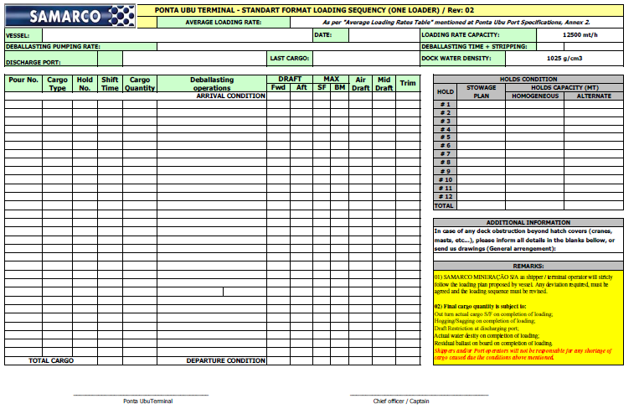



**ANNEX 8**

**MASTER’S RECEIPT OF ACKNOWLEDGEMENT**

I, as Master, hereby state that all possible diligences/measures will be exercised in name of below mentioned vessel, in order to comply with such protective guidance. Also, I post these guidance in manner to assure the compliance by crew, visitors and others person under interest of ship’s management.

I confirm that all instructions contained on this document will be disseminate to ship’s crew prior arrival, preferably on safety / training meetings. Terminal reserves the right to ask for evidences that the correct dissemination of information has been observed, including presentation of a list of participation of crewmembers on such pre-arrival safety meeting.

Acknowledged by,

VESSEL: ______________________ DATE: _________

Master’s Signature/ Ship’s Stamp: _________________________________

IMPORTANT: After signed, this page must be returned to the Terminal, thru port agents, as proof of understanding. Lack of compliance will prevent vessel of having authorization for berthing.

This form must be stamped / signed / dated for each and every call regardless vessel is customary to the port/terminal.